OGDEN’S ENCYCLOPEDIA OF RADIO HORROR—“S” Copyright © 2011 The Vanished Voices OTR Project (Michael Ogden)
`

S 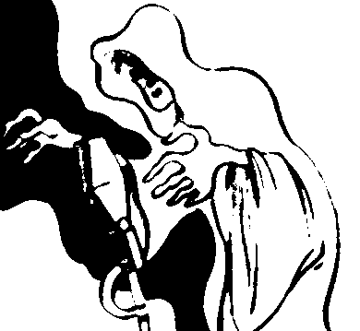

THE SHADOW OVER INNSMOUTH
[NOVELETTE]
[RADIO 4 EXTRA: “While investigating his family genealogy, a young historian is intrigued to learn about a hated and mysterious New England fishing-town called Innsmouth.”

HP LOVECRAFT—THE SHADOW OVER INNSMOUTH (RADIO 4 EXTRA, LONDON—BBC)
[Monday-Friday—6:30-7:00 PM]
October 3, 2011 [EP. 1]
[RADIO 4 EXTRA: “…Young historian Robert Olmstead journeys to the mysterious, shunned town of Innsmouth in New England…”]
SCRIPT: Paul Kent (abridged from the story by H. P. Lovecraft).
PERSONNEL: Richard Coyle (reader), Neil Gardner (producer).
October 4, 2011 [EP. 2]
[RADIO 4 EXTRA: “…Robert Olmstead explores the dark, decrepit town of Innsmouth with a growing sense of unease and terror…”]
October 5, 2011 [EP. 3]
[RADIO 4 EXTRA: “…Robert Olmstead listens to aged local drunk Zadok Allen who reveals the terrifying history of the town…”]
October 6, 2011 [EP. 4]
[RADIO 4 EXTRA: “…Robert Olmstead must spend a night in Innsmouth, but the town locals ensure he doesn’t get much sleep…”]
October 7, 2011 [EP. 5]
[RADIO 4 EXTRA: “…Robert Olmstead flees Innsmouth, only to discover years later a shocking secret linking him to the town…”]

A SHORT HISTORY OF VAMPIRES
[RADIO-SERIES]
BBC: “The vampire genre in all its dark glory.”
ORIGINATION: BBC Radio 7.
DURATION: February 13-March 6, 2011.
PERSONNEL: Genevieve Adam (reader—“Quid Pro Quo”), Mark Bonnar (reader—“Israbel”), Nick Briggs (announcer), Claire Harry (reader—“Israbel”), Natalie Haynes (presenter), David Horovitch (reader—“Hero Dust”), Gemma Jenkins (abridger, producer), Dan Stevens (reader—“Dracula’s Guest”).
EXTANT RECORDINGS: Yes.

A SHORT HISTORY OF VAMPIRES (RADIO 7—BBC)
[Sunday—6:30-7:00 PM]
February 13, 2011 “Dracula’s Guest” (by Bram Stoker)
[BBC SCHEDULE: “…Natalie Haynes introduces a tale with the greatest vampire of all…”]
February 20, 2011 “Hero Dust” (by Kristine Kathryn Rusch)
[BBC SCHEDULE: “…Natalie Haynes introduces another vampire tale, featuring their arch-nemesis—the slayer…”]
February 27, 2011 “Israbel” (by Tanith Lee)
[BBC SCHEDULE: “…the tale of a dangerous obsession for a vampire and a painter…”]
March 6, 2011 “Quid Pro Quo” (by Tanya Huff)
[BBC SCHEDULE: “…Natalie Haynes introduces a deliciously noir tale of a vampire’s battle of wits to rescue a human lover…”]

THE SIGNAL MAN
(SHORT-STORY)

EVERYMAN THEATRE (
[
November 15, 1939 “The Signal Man”
SCRIPT: Lepkin and Tweed.

THE SILVER FLUTE
[RADIO-SERIES]
Early NBC fantasy series…

THE SILVER FLUTE (WJZ, NEW YORK—NBC BLUE)
[Saturday—8:30-9:00 PM]
April 19, 1930
[ROCHESTER DEMOCRAT AND CHRONICLE: “…The Silver Flute episode…tonight will tell how Marco saves a youth ordered from home by an unjust uncle. Marco tells the tale of two brothers who are the great iron masters of a valley. The wealth of the mines keeps alive a seemingly endless river of food, drink, and merriment. Through treachery relatives sell guns to the enemy and suceed [sic] in having the flame fall upon the brothers. The great mines are confiscated, and hunted and starved, the brothers take refuge in the mountains…”]

SOME MUST WATCH/THE SPIRAL STAIRCASE
[NOVEL; MOTION-PICTURE]

THE HELEN HAYES THEATER (CBS)
[Sunday—
May 4, 1941 “Some Must Watch”
[MILWAUKEE SENTINEL: “…Helen Hayes is starred as Helen Kapel in a radio adaptation of Ethel Lina White’s new psychological horror novel, ‘Some Must Watch,’ in the famous actress’ own radio theater…”]
[YOUNGSTOWN VINDICATOR: “…It is all about a homicidal maniac who had been murdering young girls in the Maine woods…”]

SOMETHING WICKED THIS WAY COMES
[NOVEL]
First published in 196?, Something Wicked This Way Comes was Ray Bradbury’s novel-length expansion on his short story “Black Ferris” (Weird Tales, 1948).

SATURDAY PLAY (RADIO 4 FM, LONDON—BBC)
[Saturday—2:30-3:30 PM]
October 29, 2011 “Something Wicked This Way Comes”
[BBC RADIO 4: “…Set in 1960s Illinois, this gem of modern Gothic literature is the memorable story of two boys, James Nightshade and William Halloway, and the evil that grips their small Midwestern town with the arrival of a ‘dark carnival’, one Autumn midnight. These two innocents, both aged 13 (Will is born one minute before Halloween, and Jim one minute after) save the souls of the town (as well as their own). This is a vivid variation on the eternal theme of the fight between Good and Evil. A thrilling, chilling, richly kaleidoscopic sound world ensues, a shimmering mirror maze that reflects your older or younger self, depending on your desires, and a magic carousel that plays Chopin’s Funeral March forwards—with each rotation you gain a year, and rotating backwards—you get younger. The cast includes Kenneth Cranham as the sinister tattooed ringmaster, Mr. Dark, and Henry Goodman as Will’s insecure father, Charlie…”]
SCRIPT: Diana Griffiths (adapted from the novel by Ray Bradbury).
PERSONNEL: Paul Cargill (sound), Pauline Harris (producer-director), David Paul Jones (composer).
CAST: Barbara Barnes (Miss Foley), Ethan Brooke (Jed), Amelia Clarkson (Young Miss Foley), Kenneth Cranham (Mr. Dark), Buffy Davis (The Dust Witch), Henry Goodman (Charlie), Theo Gregory (Will), Josef Lindsay (Jim), Gerard McDermott (The Lightening Rod Salesman/Mr. Coogar), Taran Stanzler (Robert).
EXTANT RECORDING

THE SOUND OF FEAR
[RADIO-SPECIAL]
[BBC RADIO 4: “A door creaks, footsteps echo, someone’s breathing—and we are terrified. But why? Sean Street investigates the psychology of fear, so potently sensitive to sound.
“He hears from musician and writer David Toop and film-maker Chu-Li Shrewring how sounds trigger fear and the way this inspires them. The neuro-scientist Sophie Scott explains how our brains process terror.
“Context is important: anomalous noises, disembodied voices and sounds whose origins are mysterious—all these frighten us. David Hendy reveals that, in its early day, radio itself was alarming. Louis Niebur, author of a book on the BBC’s Radiophonic Workshop, reveals how in the 1950s, the advent of electronic sounds allowed programme-makers to use sounds that frightened people because they didn’t know what made the noises. Sound researcher Marcus Leadley explains how this triggers a state called schizophonia.
“Sean also questions whether sound and fear are culturally specific, and hears about an experiment with the Himba, a nomadic people in Nambia. Do they recognize our expressions of fear, and do we theirs?
“Nigel Paterson, director of ‘Planet Dinosaur’ explains how his team created sounds for animals about whose calls we know next to nothing. Sean hears, too, a drill sergeant-major whose voice is, in reality, very scary. And in an anechoic chamber, Sean experiences what might be the most frightening sound of all—absolute silence.
“Through the whole programme are woven an array of scary sounds, noises and music, from foxes fighting in the north London night to cicadas in the jungle, from the voices of the Daleks to the music from the film ‘Psycho,’ and from a tiger to a rain drop. That, and some Freud, too, in The Sound of Fear.”

(RADIO 4, LONDON—BBC)
[Tuesday—9:00-9:30 PM]
October 18, 2011 “The Sound of Fear”
PERSONNEL: Julian May (producer), Sean Street (interviewer).
EXTANT RECORDING

STAY TUNED FOR TERROR
[RADIO-SERIES]
Robert Bloch’s legendary radio series from 1945…
[Milwaukee Journal, November 21, 1944—“Horror Is Hot Stuff Now; Milwaukeean Cashing In” by Harold Gauer] “‘Yours truly, Jack the Ripper’ sent chills tingling down the spines of Milwaukee horror fans some months ago on the Kate Smith radio show. Laird Cregar took the part of the mad killer, whose weird crimes were dramatized for the program by Milwaukee’s horror story writer, Robert Bloch.
“Robert Bloch has been dishing out horror for his fans in the pulp magazines for almost a decade but is a mild mannered gent who wouldn’t hit a mosquito unless it bit him first. He seldom, if ever, wakes up screaming, and even his year old baby girl fails to see anything disconcerting in her daddy’s face making over the typewriter.
“The current popularity of the horror show, both on the radio and in the movies, has been building up for a long time. Boris Karloff, Bela Lugosi and Lon Chaney, jr., have pioneered the art for the films, and Peter Lorre, Laird Cregar and Basil Rathbone have moaned, chattered and snarled the weird radio programs into top billing. All of this has required a very special kind of scripting. Stalking in the background of their present popularity are the pulp paper magazines, Weird Tales, Fantastic Adventures, etc., from which many of the present day themes are taken, like zombies, from the dead, to walk again.
“Today the horror market is prospering as it never has prospered before, and Author Bloch, listening to the squeaking door of the ‘Inner Sanctum,’ the blood curdling screams in ‘Mystery Playhouse,’ and the sibilant terror of ‘Suspense,’ is writing more furiously than ever—for the pulps.
“As the ‘Mad Scientist’ pursues his creation, the ‘Mad Monster,’ hypodermic needle in hand, across the screens of thousands of movie houses, Author Bloch sticks to the pulp magazines.
“‘The pulp story, however formalized,’ says Bloch, ‘demands a much higher literary quality and infinitely more original plotting than the average ingredient of the ‘Gruesome Twosome’ screen play. The real horror fan,’ he explains, ‘wants authentic tales, based either on known myths and legends (or even fairy stories), or else on historical fact, such as the Jack the Ripper stuff.
“The dyed in the wool reader—the kind that appreciate Bloch’s ‘Feast in the Abbey,’ ‘Druidic Doom’ and ‘The Faceless God’ simply would not stand for any ‘Mad Doctor’ business.
PHOTO CAPTION: “This is a picture of Robert Bloch of Milwaukee, but honestly he doesn’t look this menacing most of the time. He doesn’t even look this sinister when batting out a horror tale for a pulp magazine. Bloch has been writing horror stories for 10 years. He started when only 15. The picture was taken by Harold Gauer, a horror fan.”

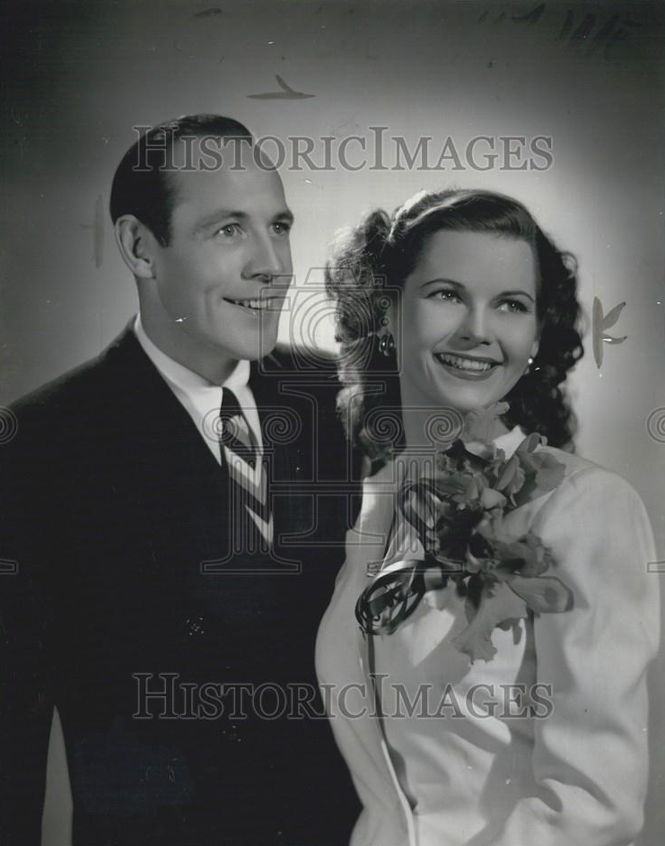

Original Press Photo of Radio Stars Johnny Neblett, Angelyn Orr. Chicago IL.. Photo is dated: 12/19/1945.

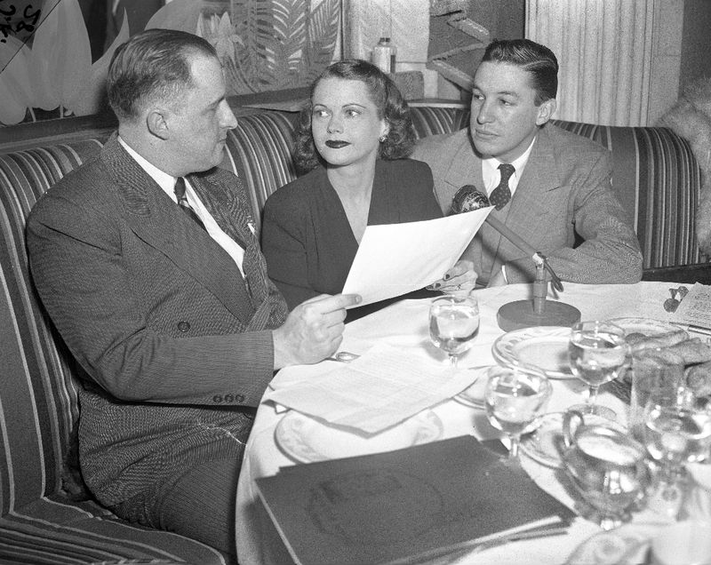

This is an original 4x5 negative of Arnold Rauen, Illinois state director of the U.S. Treasury Department, actree Angeline Orr Neblett, and Mike Wallace, January 22, 1947 in the Balinese Room. Angeline was given a posthumous award for Johnny Neblett. Johnny Neblett, the producer of the series,Stay Tuned For Terror, with his Neblett Radio Productions company tragically died in a plane crash in 1946, at the age of only 33. Contemporaneous accounts of the plane crash state that he'd only "recently" begun his Neblett Radio Productions company, which would coincide well with Robert Bloch's interview comments. Bloch had stated that his friend, Johnny Neblett helped him put together the concept for Stay Tuned for Terror, by forming his own production company--Neblett Radio Productions. Angeline Orr, one of the actresses for the series, married Mr. Neblett during the course of the recording sessions for Stay Tuned for Terror.

A STIR OF ECHOES

A Stir of Echoes
When Tom Wallace is hypnotised by his brother-in-law it awakens psychic abilities he never knew he possessed. Richard Matheson’s thriller is abridged by Neville Teller, read by Trevor White and produced by Heather Larmour.
Monday to Friday at 6.30am,1pm, 8pm and 1am

THE STRANGE DOCTOR KARNAC
[RADIO-SERIES]
[

THE STRANGE DOCTOR KARNAC (
[
January 23, 1943
[YOUNGSTOWN VINDICATOR: “…a new series of weird, fantastic tales based on the occult and supernatural, will make its bow. Written by Scott Bishop, the series will bring to the loudspeaker a startling new character and sleuth who trails sinister figures who employ ‘black magic’ in their villainous trade…”]

STRANGE TALES
[RADIO-SERIES]
Extremely short-lived anthology series on WHAM in Rochester…”broadcast from the studios of WHAM…”

STRANGE TALES (WHAM, ROCHESTER)
[Monday—8:30-9:00 PM]
May 19, 1930 “The Monkey’s Paw”
[ROCHESTER DEMOCRAT AND CHRONICLE: “…At 8:30 o’clock this evening WHAM inaugurates ‘Strange Tales,’ a new series of mysteries and melodramas. ‘The Monkey’s Paw,’ by W. W. Jacobs, portraying a clash between Hindoo mysticism and middle class skepticism, and the consequent disaster to a little family living just outside of London, is the first play to be presented…”]
CAST: Richard Brodhead, Harold E. Cowles, Hazel Cowles, Jesse Ogden, Jack Ross.
May 26, 1930 “The Widow of Wasdale Head”
[ROCHESTER DEMOCRAT AND CHRONICLE: “…fantasy in one act by Sir Arthur Wing Pinero, noted English playwright, will be heard as the second in the new series of dramatic productions known as ‘Strange Tales’…. Romance as well as mystery is incorporated in the drama…”]
CAST: Richard Brodhead, Hazel Cowles, Jack Lee, Jesse Ogden, Jacob Ross.
June 2, 1930 NYT
June 9, 1930 NYT

SWEENEY TODD
[FOLK-LEGEND; STAGE-PLAY]

JULY 13, 1925:
[Kingston Daily Freeman—“Only Legends Tell About Sweeney Todd”]
“A report to the effect that the house on Fleet street, London, formerly occupied by Sweeney Todd has been discovered gives rise to the question: ‘Who is Sweeney Todd?’ He was rather a mythical person and his existence is accounted for largely by unproved legends. The story goes that Sweeney Todd was a barber of Fleet street, who had an unpleasant way with his customers. For, according to tradition, if anyone came for a shave who looked worth robbing, he would seat the man in a chair which would presently capsize and throw the occupant into a well or vault below. There, it was said, he would rob the unfortunate fellow and afterward dispose of the body to a confederate who kept a pie shop in the adjoining house, whose bakehouse communicated with the vaults of St. Dunstan’s church. While the legend says that Todd was hanged at Tyburn, the annals of Newgate have nothing about him. But Sweeney Todd was sufficiently famous to figure in many old ballads and melodramas.”

DECEMBER 12, 1940:
[Salt Lake Tribune—“Screen’s Top Villainess, But Hates It” by Alexander Kahn]
“If you hate Rafaela Ottiano, one of the screen's better villainesses, you are not alone in your attitude—for Miss Ottiano hates herself. So thoroughly does she dislike herself as she appears on the screen that she doesn't even see the daily "rushes" and even waits a long time, sometimes six
months or a year, before she sees a picture in which she has appeared.
"‘I can't look myself in the face,’ laments Miss Ottiano, who currently is playing the part of a sinister housekeeper in the Hal Roach mystery-comedy, ‘Topper Returns.’ ‘If they ever give me a
chance to play a nicer character, I might get over the idea that I'm such a detestable person. But I don't suppose I'll ever have the chance. And I feel that if I'm destined to be a menace, I might as well do a workmanlike job of it.’
“And she does. For when Miss Ottiano steps into a scene, the audience immediately knows she is bad. That reaction brands Miss Ottiano as a dyed-in-the-wool, full-time menace.
“In fact , she can put more menace in a simple act, like winding a clock, than most other actors could while strangling a child.
“Miss Ottiano says that frequently persons meeting her for the first time face to face are uneasy.
"‘They act as if I were carrying a concealed weapon,’ she says. ‘That's all right with me. It is something of a testimonial to my work as a screen villainess.’"

(WOR, NEW YORK)
[Monday—3:30-3:50 PM] ???
July 21, 1924 “Sweeney Todd or The String of Pearls”
[BRIDGEPORT TELEGRAM: “…Scenes from the English melodrama ‘Sweeney Todd or The String of Pearls,’ now playing at the Frazee Theater, New York City…”]

